Supplementary material

Supplementary Table 1. Distribution of the 18 hr-HPV genotypes.
hr-HPV genotype |  | Non-malignant | CIN I | CIN II | CIN III | Cervical cancer | Total | p-value
HPV16
 | Negative | 98 (90.7%) | 23 (79.3%) | 15 (71.4%) | 18 (64.3%) | 2 (100.0%) | 156 (83.0%) | 0.050
 | Positive | 10 (9.3%) | 6 (20.7%) | 6 (28.6%) | 10 (35.7%) | 0 (0.0%) | 32 (17.0%)
HPV18
 | Negative | 105 (97.2%) | 29 (100.0%) | 20 (95.2%) | 28 (100.0%) | 1 (50.0%) | 183 (97.3%) | 0.065
 | Positive | 3 (2.8%) | 0 (0.0%) | 1 (4.8%) | 0 (0.0%) | 1 (50.0%) | 5 (2.7%)
HPV31
 | Negative | 106 (98.1%) | 28 (96.6%) | 20 (95.2%) | 27 (96.4%) | 2 (100.0%) | 183 (97.3%) | 0.493
 | Positive | 2 (1.9%) | 1 (3.4%) | 1 (4.8%) | 1 (3.6%) | 0 (0.0%) | 5 (2.7%)
HPV33
 | Negative | 107 (99.1%) | 29 (100.0%) | 19 (90.5%) | 23 (82.1%) | 2 (100.0%) | 180 (95.7%) | 0.030*
 | Positive | 1 (0.9%) | 0 (0.0%) | 2 (9.5%) | 5 (17.9%) | 0 (0.0%) | 8 (4.3%)
HPV35
 | Negative | 108 (100.0%) | 26 (89.7%) | 21 (100.0%) | 27 (96.4%) | 2 (100.0%) | 184 (97.9%) | 0.020*
 | Positive | 0 (0.0%) | 3 (10.3%) | 0 (0.0%) | 1 (3.6%) | 0 (0.0%) | 4 (2.1%)
HPV39
 | Negative | 104 (96.3%) | 27 (93.1%) | 20 (95.2%) | 27 (96.4%) | 2 (100.0%) | 180 (95.7%) | 0.896
 | Positive | 4 (3.7%) | 2 (6.9%) | 1 (4.8%) | 1 (3.6%) | 0 (0.0%) | 8 (4.3%)
HPV45
 | Negative | 108 (100.0%) | 29 (100.0%) | 21 (100.0%) | 28 (100.0%) | 2 (100.0%) | 188 (100.0%) | –
HPV51
 | Negative | 102 (94.4%) | 22 (75.9%) | 19 (90.5%) | 27 (96.4%) | 2 (100.0%) | 172 (91.5%) | 0.037*
 | Positive | 6 (5.6%) | 7 (24.1%) | 2 (9.5%) | 1 (3.6%) | 0 (0.0%) | 16 (8.5%)
HPV52
 | Negative | 86 (79.6%) | 22 (75.9%) | 16 (76.2%) | 26 (92.9%) | 1 (50.0%) | 151 (80.3%) | 0.233
 | Positive | 22 (20.4%) | 7 (24.1%) | 5 (23.8%) | 2 (7.1%) | 1 (50.0%) | 37 (19.7%)
HPV53
 | Negative | 103 (95.4%) | 24 (82.8%) | 18 (85.7%) | 28 (100.0%) | 2 (100.0%) | 175 (93.1%) | 0.038*
 | Positive | 5 (4.6%) | 5 (17.2%) | 3 (14.3%) | 0 (0.0%) | 0 (0.0%) | 13 (6.9%)
HPV56
 | Negative | 106 (98.1%) | 27 (93.1%) | 21 (100.0%) | 26 (92.9%) | 2 (100.0%) | 182 (96.8%) | 0.218
 | Positive | 2 (1.9%) | 2 (6.9%) | 0 (0.0%) | 2 (7.1%) | 0 (0.0%) | 6 (3.2%)
HPV58
 | Negative | 98 (90.7%) | 25 (86.2%) | 17 (81.0%) | 22 (78.6%) | 1 (50.0%) | 163 (86.7%) | 0.134
 | Positive | 10 (9.3%) | 4 (13.8%) | 4 (19.0%) | 6 (21.4%) | 1 (50.0%) | 25 (13.3%)
HPV59
 | Negative | 103 (95.4%) | 28 (96.6%) | 20 (95.2%) | 27 (96.4%) | 2 (100.0%) | 180 (95.7%) | >0.999
 | Positive | 5 (4.6%) | 1 (3.4%) | 1 (4.8%) | 1 (3.6%) | 0 (0.0%) | 8 (4.3%)
HPV66
 | Negative | 107 (99.1%) | 27 (93.1%) | 20 (95.2%) | 27 (96.4%) | 2 (100.0%) | 183 (97.3%) | 0.173
 | Positive | 1 (0.9%) | 2 (6.9%) | 1 (4.8%) | 1 (3.6%) | 0 (0.0%) | 5 (2.7%)
HPV68
 | Negative | 102 (94.4%) | 27 (93.1%) | 20 (95.2%) | 27 (96.4%) | 2 (100.0%) | 178 (94.7%) | 0.960
 | Positive | 6 (5.6%) | 2 (6.9%) | 1 (4.8%) | 1 (3.6%) | 0 (0.0%) | 10 (5.3%)
HPV73
 | Negative | 108 (100.0%) | 29 (100.0%) | 20 (95.2%) | 27 (96.4%) | 2 (100.0%) | 186 (98.9%) | 0.111
 | Positive | 0 (0.0%) | 0 (0.0%) | 1 (4.8%) | 1 (3.6%) | 0 (0.0%) | 2 (1.1%)
HPV82
 | Negative | 108 (100.0%) | 29 (100.0%) | 21 (100.0%) | 28 (100.0%) | 2 (100.0%) | 188 (100.0%) | -
HPV83
 | Negative | 0 (0.0%) | 1 (3.4%) | 0 (0.0%) | 0 (0.0%) | 0 (0.0%) | 1 (0.5%) | 0.426
 | Positive | 108 (100.0%) | 28 (96.6%) | 21 (100.0%) | 28 (100.0%) | 2 (100.0%) | 187 (99.5%)
*p < 0.05

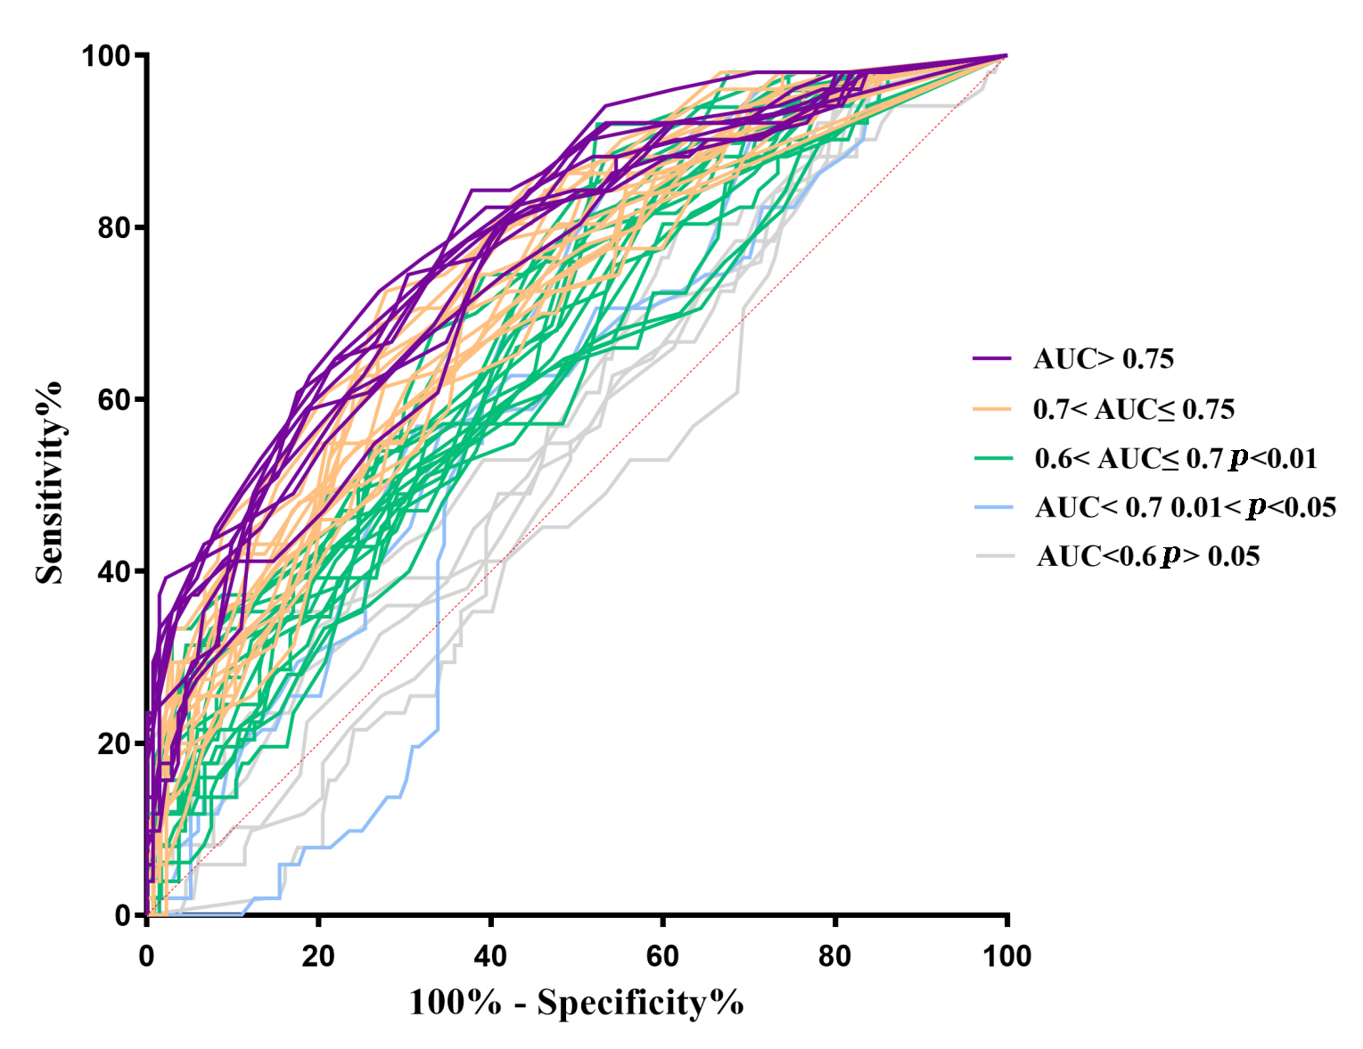
Supplementary Fig. 1. ROC curves for the 88 PAX1 methylation sites. PAX1, paired box-1; ROC, receiver operating characteristic.

